Security Lab
Project Title
Comparative File Encryption Tool using AES, DES and GUI Dashboard


Submitted To:- Submitted By:- Mr. Santosh Gupta Yashasvi Bhati

Branch:- Computer Science and Engineering
College Name:- Jodhpur Institute Of Engineering and Technology
Section:6C3
Year:- 3nd

Abstract
In the modern digital era, securing sensitive information has become a major concern due to increasing cyber threats, data breaches, and unauthorized access. Encryption is one of the most effective techniques used to protect data confidentiality and integrity. This project presents the design and implementation of a File Encryption and Decryption Tool that supports multiple encryption algorithms, including AES (Advanced Encryption Standard), DES (Data Encryption Standard), and a basic encryption method (Fernet), integrated into a centralized graphical dashboard.
The system provides a user-friendly interface that allows users to select files, encrypt or decrypt them using a password, and process multiple files simultaneously. The AES algorithm is implemented using AES-256 with CBC mode and PBKDF2 key derivation, ensuring high security. The DES algorithm is included for comparative analysis to demonstrate differences in security and performance.
The project also includes advanced features such as multi-file encryption, password-based security, graphical user interface (GUI), and a centralized dashboard for selecting encryption methods. This tool demonstrates practical implementation of cryptographic concepts and highlights the importance of encryption in protecting digital data.

Introduction
With the rapid advancement of digital technologies, vast amounts of data are being stored and transmitted electronically. This data includes sensitive information such as personal records, financial details, business documents, and confidential communications. As cyber threats continue to evolve, ensuring the security and privacy of such data has become a critical challenge.
Encryption is a fundamental technique used in cybersecurity to protect data by converting it into an unreadable format. Only authorized users with the correct key or password can decrypt the data and access its original form. Various encryption algorithms have been developed over time, among which DES and AES are widely studied.
This project focuses on developing a comprehensive file encryption system that integrates multiple encryption algorithms into a single application. The system allows users to perform encryption and decryption operations using a graphical interface, making it accessible even to non-technical users.
The project not only demonstrates the implementation of encryption techniques but also provides a comparative analysis of different algorithms, highlighting their strengths and weaknesses. The inclusion of a centralized dashboard and multi-file processing enhances usability and efficiency, making the system more practical and scalable.

3. Objectives
The main objectives of this project are:
- To understand and implement encryption and decryption techniques.
- To develop a system that supports multiple encryption algorithms (AES, DES, Fernet).
- To design a user-friendly graphical interface for easy interaction.
- To implement password-based encryption for enhanced security.
- To enable multi-file encryption and decryption.
- To compare the performance and security of AES and DES algorithms.
- To demonstrate the practical application of cryptography in real-world scenarios.

4. System Architecture
The system architecture consists of multiple layers that work together to perform encryption and decryption operations.

Components:
- User Layer
  - Interacts with the system through GUI
  - Selects files and encryption type
- Application Layer
  - Dashboard (main_dashboard.py)
  - AES Module
  - DES Module
  - Basic Encryption Module
- Security Layer
  - AES-256 Encryption (CBC Mode)
  - DES Encryption
  - Password-based key generation (PBKDF2)
- Storage Layer
  - Input files (txt, pdf, images)
  - Encrypted files
  - Key handling (password-based)
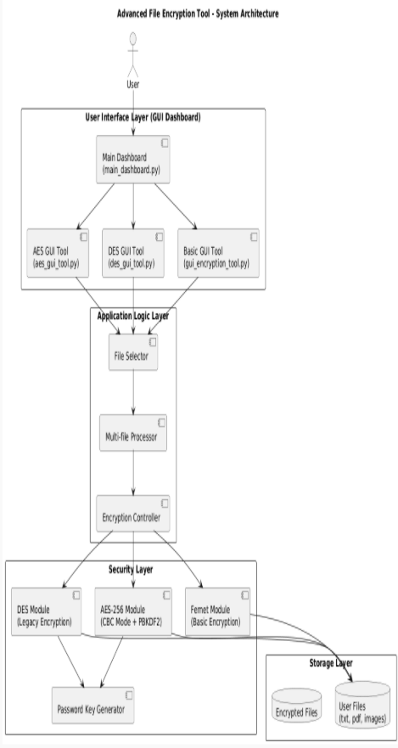
Folder Structure
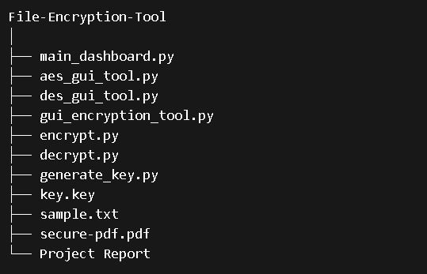

Working of the System
The system works in the following steps:
- The user launches the main dashboard.
- The user selects an encryption method:
  - AES (Advanced)
  - DES (Legacy)
  - Basic (Fernet)
- The user selects one or multiple files.
- The user enters a password.
- The system generates a secure key from the password.
- The selected files are encrypted using the chosen algorithm.
- The encrypted files become unreadable.
- For decryption, the same password is required.
- The system decrypts the file and restores the original content.

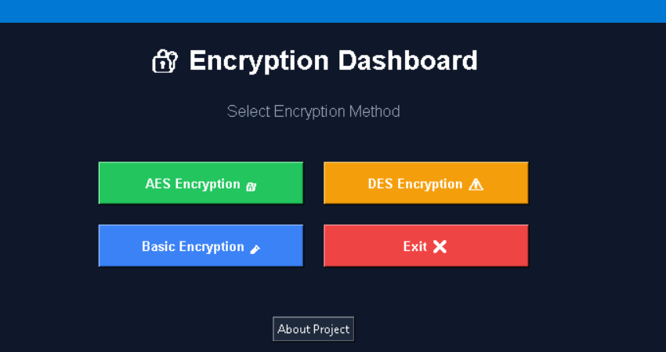

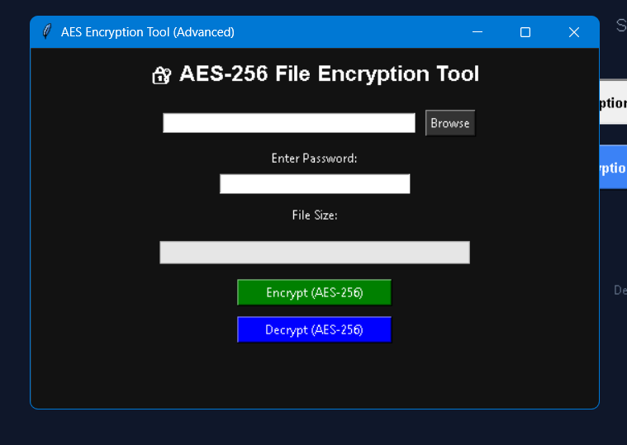

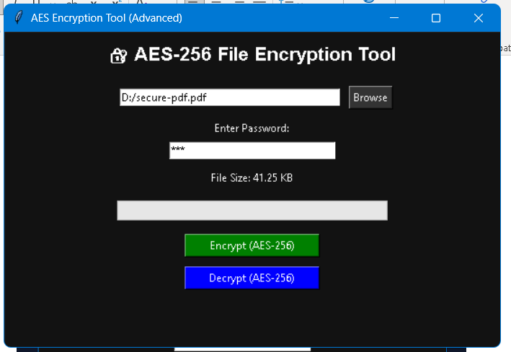

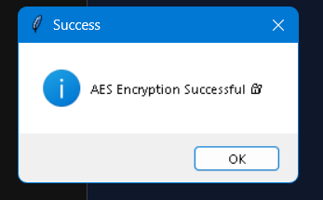

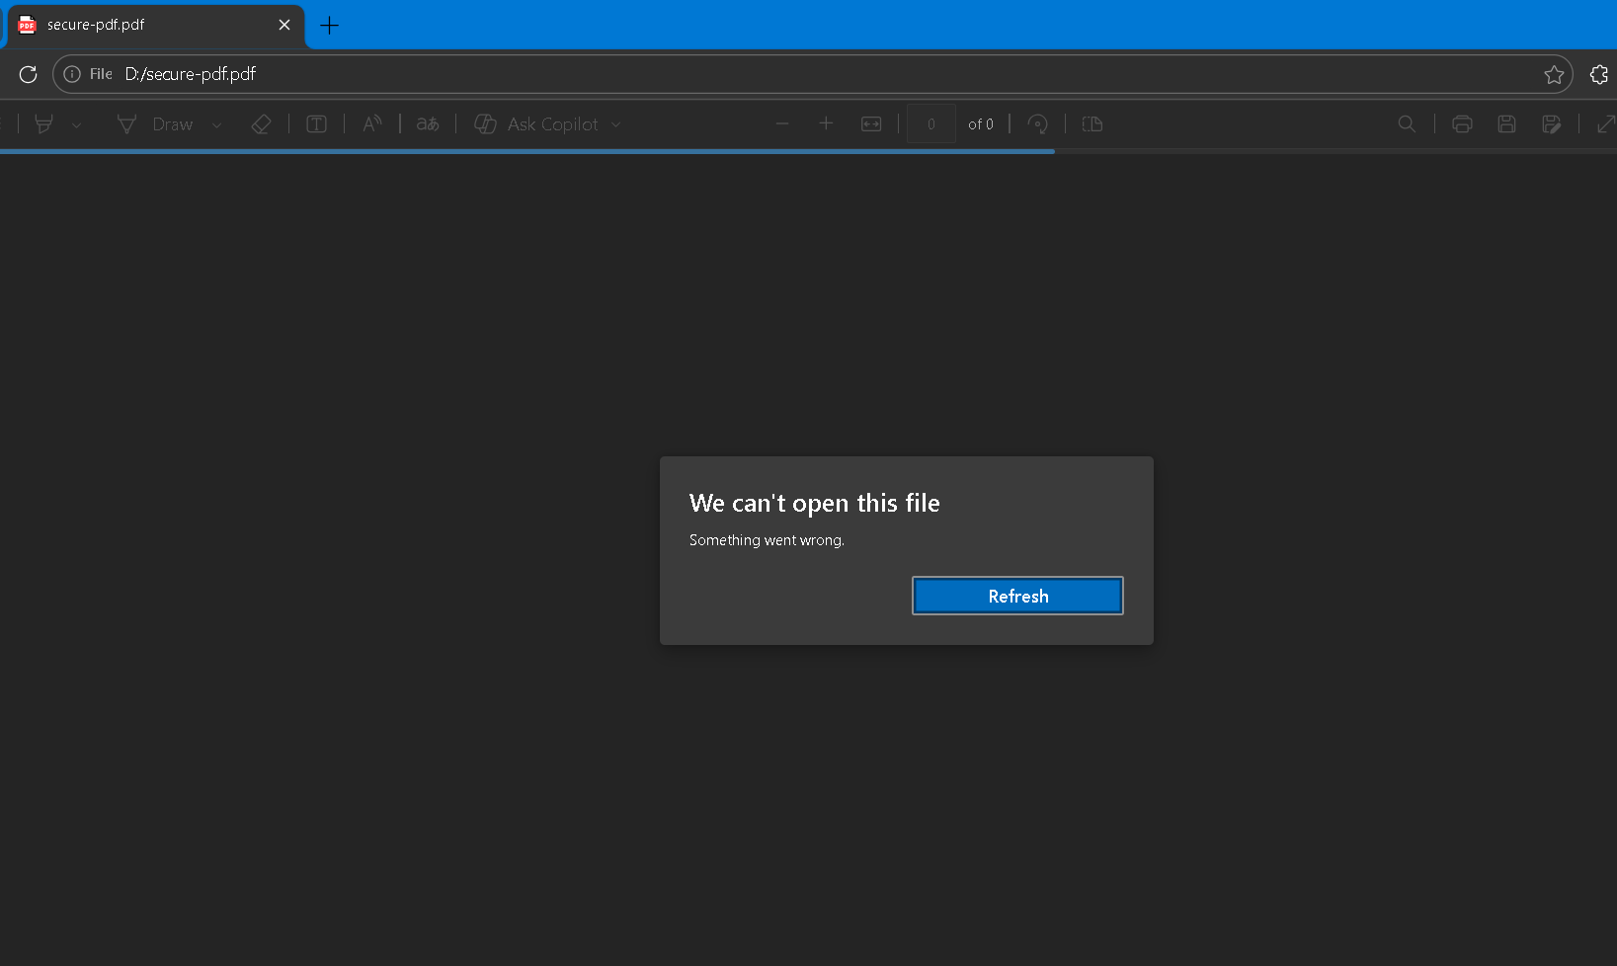

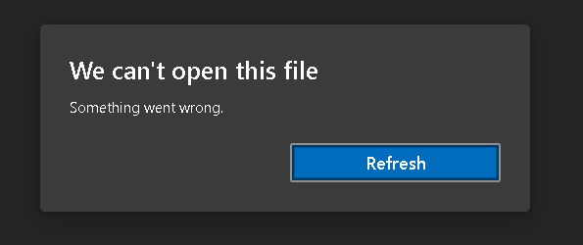

Comparison of Encryption Techniques

Feature | DES | AES | Fernet
Key Size | 56-bit | 128/192/256-bit | 128-bit
Security | Weak | Very Strong | Strong
Speed | Slow | Fast | Moderate
Usage | Deprecated | Modern Standard | Simplified AES
Vulnerability | High | Very Low | Low

How to Run the Project
Step 1: Install dependencies
pip install cryptography
pip install pycryptodome
Step 2: Run dashboard
python main_dashboard.py

Step 3: Use GUI
- Select encryption type
- Select file(s)
- Enter password
- Click Encrypt / Decrypt

Use Case Diagram

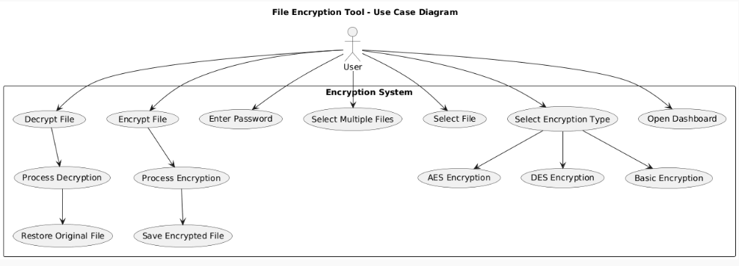

Applications
The Comparative File Encryption Tool using AES, DES, and GUI Dashboard has a wide range of applications in modern digital environments where data security is a primary concern. With the increasing dependency on digital platforms for storing and sharing information, protecting sensitive data has become essential. This system provides a practical solution for securing files through encryption, ensuring confidentiality and preventing unauthorized access.
One of the major applications of this system is in protecting confidential files. Organizations handle large amounts of sensitive information such as financial records, employee data, business strategies, and legal documents. If such data is exposed, it can lead to severe consequences including financial loss and reputational damage. By encrypting files using strong algorithms like AES, the system ensures that even if the data is accessed by unauthorized users, it remains unreadable without the correct password.
Another important application is in secure file storage systems. Many individuals and organizations store data on local machines, external drives, or cloud platforms. However, these storage systems are vulnerable to cyber attacks, theft, or unauthorized access. Encrypting files before storing them adds an additional layer of protection. Even if the storage medium is compromised, the encrypted data cannot be accessed without the decryption key.
The system is also useful in secure file sharing and transmission. Files shared over the internet via email, cloud services, or messaging platforms can be intercepted by attackers. Encrypting files before transmission ensures that only the intended recipient with the correct password can access the content. This is particularly important in industries such as banking, healthcare, and government sectors where data confidentiality is critical.
Another application is in cybersecurity education and training. This project serves as an excellent learning tool for students and professionals who want to understand how encryption works in real-world scenarios. By implementing multiple algorithms such as AES and DES, users can compare their performance and security levels, gaining deeper insights into cryptographic techniques.
The tool can also be applied in personal data protection. Individuals often store personal files such as identity documents, passwords, photos, and financial records.
Advantages
The Comparative File Encryption Tool offers several advantages that make it an effective solution for securing digital data. One of the most important advantages is data confidentiality. By encrypting files, the system ensures that sensitive information is converted into an unreadable format, preventing unauthorized access.
Another key advantage is the use of advanced encryption algorithms such as AES-256, which is widely regarded as one of the most secure encryption standards available today. This provides strong protection against cyber attacks, brute-force attempts, and unauthorized data access.
The system also provides a comparative analysis of encryption algorithms, including AES, DES, and basic encryption techniques. This helps users understand the differences in security levels, performance, and usability of each algorithm. Including DES in the system allows users to study legacy encryption methods and understand why they are no longer considered secure.
A major advantage of the project is its user-friendly graphical interface. The GUI makes it easy for users to interact with the system without requiring technical knowledge. Users can select files, choose encryption methods, and perform operations using simple buttons, making the system accessible to a wide range of users.
Another important feature is multi-file encryption, which allows users to encrypt or decrypt multiple files simultaneously. This improves efficiency and saves time, especially when dealing with large amounts of data.
The system also supports password-based encryption, eliminating the need for storing separate key files. This enhances security and convenience, as users only need to remember a password to access their encrypted data.
The centralized dashboard design is another significant advantage. It integrates multiple encryption modules into a single interface, allowing users to switch between different encryption methods easily. This modular design also makes the system scalable and easy to extend with additional features.

Conclusion
In the current digital age, where data is one of the most valuable assets, ensuring its security has become a top priority. The Comparative File Encryption Tool using AES, DES, and GUI Dashboard successfully addresses this need by providing a comprehensive solution for securing digital files through encryption.
The project demonstrates the implementation of multiple encryption algorithms, including AES, DES, and basic encryption techniques, within a single system. By integrating these algorithms into a centralized dashboard, the system provides both functionality and educational value. Users can not only secure their files but also understand the differences between various encryption methods.
The use of AES-256 encryption with password-based key generation ensures a high level of security, making the system suitable for protecting sensitive information. The inclusion of DES allows users to study legacy encryption methods and understand their limitations, while the basic encryption module provides a foundation for learning cryptographic concepts.
The addition of advanced features such as multi-file encryption, graphical user interface, and centralized dashboard enhances the usability and efficiency of the system. These features make the tool practical for real-world applications, including secure file storage, data transmission, and personal data protection.
This project also highlights the importance of encryption in modern cybersecurity systems. It demonstrates how simple tools can be used to protect data from unauthorized access and cyber threats. The knowledge gained from this project can be applied to more advanced security systems and applications.
In conclusion, the project successfully achieves its objectives by developing a secure, user-friendly, and scalable file encryption system. It provides both practical functionality and theoretical understanding, making it a valuable contribution to the field of cybersecurity. With further enhancements, this system can be extended into a full-fledged security application capable of handling large-scale data protection requirements.

